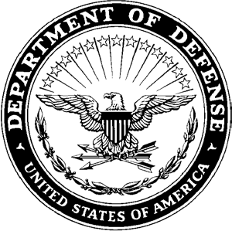**DEPARTMENT OF THE ARMY**

**HEADQUARTERS, AIRBORNE and RANGER TRAINING BRIGADE 10850 SCHNEIDER ROAD**

**FORT MOORE, GEORGIA 31905-5000**

ATSH-RB 16 January 2025

MEMORANDUM FOR Airborne and Ranger Training Brigade

SUBJECT: [INSERT UNIT] Competitors for the 41st Annual LTG(R) David E. Grange Jr. Best Ranger Competition

1. The Soldiers listed below have been assessed and selected by the Commander to represent the [INSERT UNIT] in the 41st Annual LTG (R) David E. Grange Jr. Best Ranger Competition:
   1. Team 1
      1. RANK last, name, first name (DODID)
      2. RANK last, name, first name (DODID)
   2. Team 2
      1. RANK last, name, first name (DODID)
      2. RANK last, name, first name (DODID)
2. The Soldier listed above have successfully complete a unit assessment that included the following events:
   1. Ranger Physical Assessment
   2. 12-mile foot march in 3 hours with a minimum of 35lb rucksack, not including water weight.
   3. Combat water survival assessment consisting of a 15-meter swim in ACUs and boots.
   4. Basic Rifle Marksmanship
   5. Tactical Combat Casualty Care (TCCC)
3. The POC for this memorandum is the [INSERT DIV G3 (or BDE S3 if the unit is a separate BDE) POC information].

NAME

RANK, BRANCH

POSITION

|  |  |
| --- | --- |
| 17 February 2025 | Letter of Intent Due |
| 28 February 2025 | Competitor Packet Due |
| 07 March 2025 | ARTB releases by-name team list |
| 11 March 2025 | No Further Training on ARTB sites |
| April 2025 | Competitor Report Date |
| 07-10 April 2025 | Competitor Week |
| 11-13 April 2025 | Competition |
| 14 April 2025 | Award Ceremony |